AI Assisted Coding
Assignment-8.1 2303A51852 BATCH 13

Task Description #1 (Password Strength Validator – Apply AI in
Security Context)
- Task: Apply AI to generate at least 3 assert test cases for is_strong_password(password) and implement the
validator function.
- Requirements:
- Password must have at least 8 characters.
- Must include uppercase, lowercase, digit, and special character.
- Must not contain spaces. Example Assert Test Cases:
assert is_strong_password("Abcd@123") == True assert is_strong_password("abcd123") == False assert is_strong_password("ABCD@1234") == True

Expected Output #1:
- Password validation logic passing all AI-generated test cases.

Prompt:
#generate python code for strong passoword generator Password must have at least 8 characters,Must include uppercase, lowercase, digit, and special characte, Must not contain spaces.

Code:

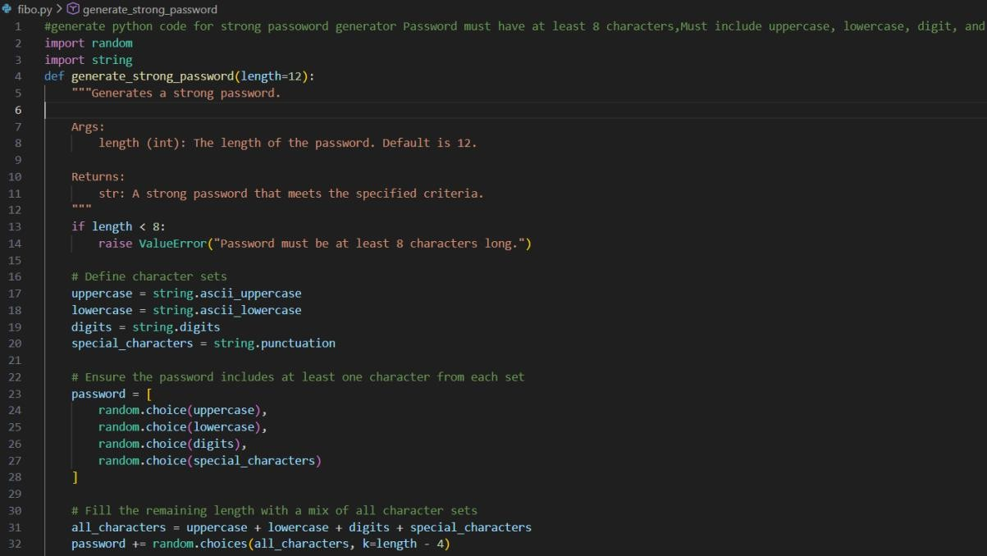

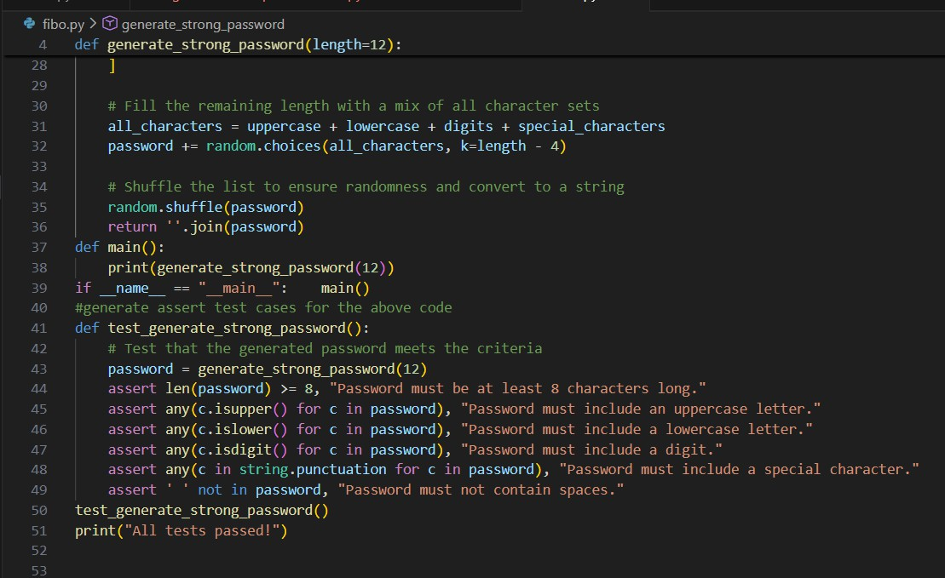

Output:
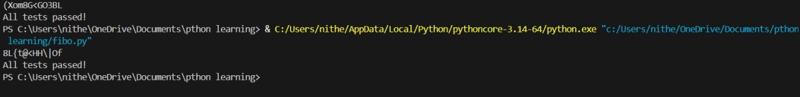

Justification:
By validating these conditions through assert test cases, we ensure the function reliably identifies strong passwords and rejects weak ones.

Task Description #2 (Number Classification with Loops – Apply
AI for Edge Case Handling)

- Task: Use AI to generate at least 3 assert test cases for a classify_number(n) function. Implement using loops.
- Requirements:
- Classify numbers as Positive, Negative, or Zero.
- Handle invalid inputs like strings and None.
- Include boundary conditions (-1, 0, 1). Example Assert Test Cases:
assert classify_number(10) == "Positive" assert classify_number(-5) == "Negative" assert classify_number(0) == "Zero" Expected Output #2:
- Classification logic passing all assert tests.

Prompt:
# generate code for number classification with loop include Classify numbers as Positive, Negative, or
Zero.Handle invalid inputs like strings and None, Include boundary conditions (-1, 0, 1).

Code:

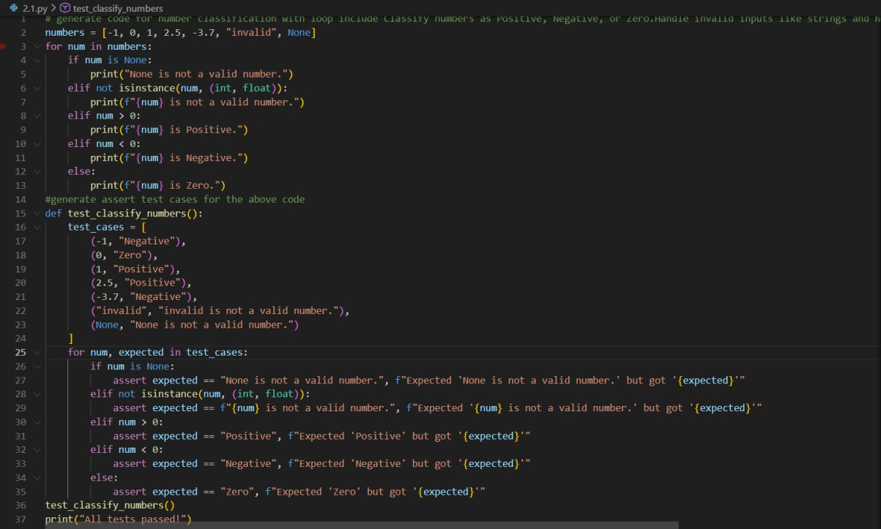

Output:
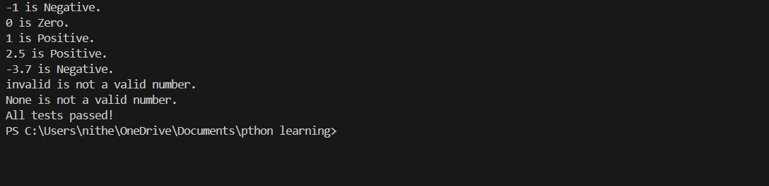

Justification:
The classification function uses loop-based logic and input validation to correctly identify positive, negative, and zero values while safely handling invalid inputs like strings or None.
By testing boundary conditions such as -1, 0, and 1 through assert statements, we ensure accurate behavior

across edge cases and prevent unexpected runtime errors.

Task Description #3 (Anagram Checker – Apply AI for String
Analysis)
- Task: Use AI to generate at least 3 assert test cases for is_anagram(str1, str2) and implement the function.
- Requirements:
- Ignore case, spaces, and punctuation.
- Handle edge cases (empty strings, identical words). Example Assert Test Cases:
assert is_anagram("listen", "silent") == True assert is_anagram("hello", "world") == False
assert is_anagram("Dormitory", "Dirty Room") == True Expected Output #3:

- Function correctly identifying anagrams and passing all AI-
generated tests

Prompt:
#generate a python code for Anagram checker that checks if two strings are anagrams of each other.Ignore case, spaces, and punctuation,Handle edge cases (empty
strings, identical words)

Code:
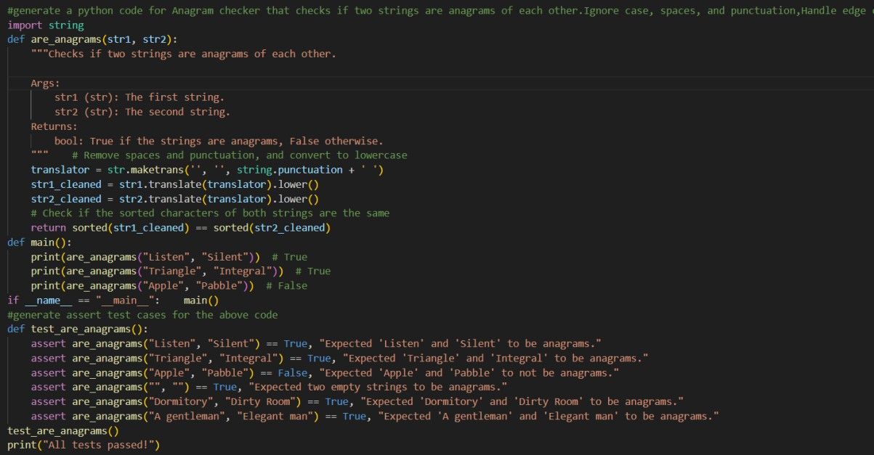

Output:

Justification:
The anagram checker normalizes input by ignoring case, spaces, and punctuation to ensure accurate comparison of character frequency between two strings.

Task Description #4 (Inventory Class – Apply AI to Simulate Real-
World Inventory System)
- Task: Ask AI to generate at least 3 assert-based tests for an
Inventory class with stock management.
- Methods:
o add_item(name, quantity)
o remove_item(name, quantity)
o get_stock(name) Example Assert Test Cases: inv = Inventory()
inv.add_item("Pen", 10)
assert inv.get_stock("Pen") == 10 inv.remove_item("Pen", 5)
assert inv.get_stock("Pen") == 5

inv.add_item("Book", 3)
assert inv.get_stock("Book") == 3 Expected Output #4:
- Fully functional class passing all assertions.

Prompt:

#generate a python code for inventory class that manages add_item(name, quantity) ,remove_item(name,
quantity),get_stock(name)

Code:

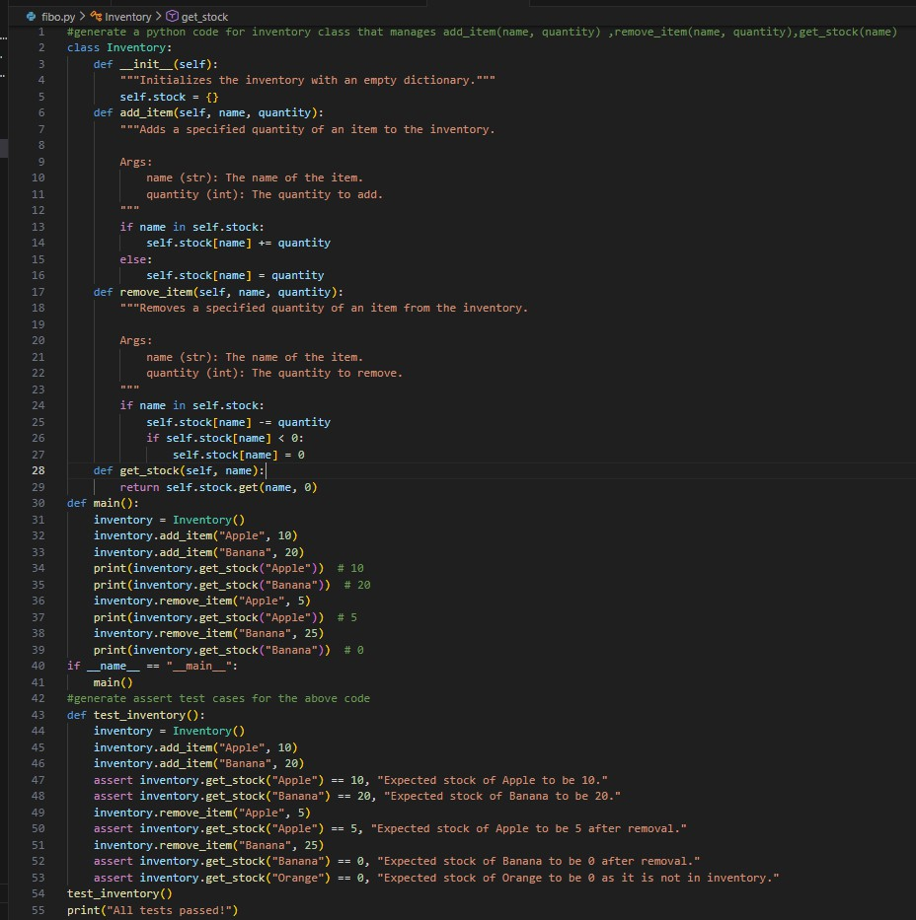

Output:
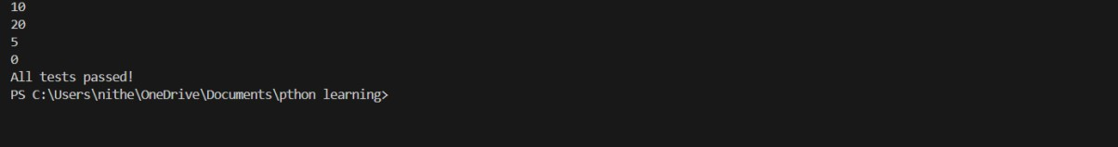

Justification:
The Inventory class ensures accurate stock updates through add and remove operations.
Assert tests confirm correct quantity tracking and reliable inventory management.

Task Description #5 (Date Validation C Formatting – Apply AI for
Data Validation)
- Task: Use AI to generate at least 3 assert test cases for validate_and_format_date(date_str) to check and convert dates.
- Requirements:
- Validate "MM/DD/YYYY" format.
- Handle invalid dates.
- Convert valid dates to "YYYY-MM-DD". Example Assert Test Cases:
assert validate_and_format_date("10/15/2023") == "2023- 10-15"
assert validate_and_format_date("02/30/2023") == "Invalid Date"

assert validate_and_format_date("01/01/2024") == "2024- 01-01"
Expected Output #5:
- Function passes all AI-generated assertions and handles edge
cases.

Prompt:
#generate a python code for Date validation and formatting class that manages Validate "MM/DD/YYYY" format,Handle invalid dates,Convert valid dates to "YYYY- MM-DD".

Code:

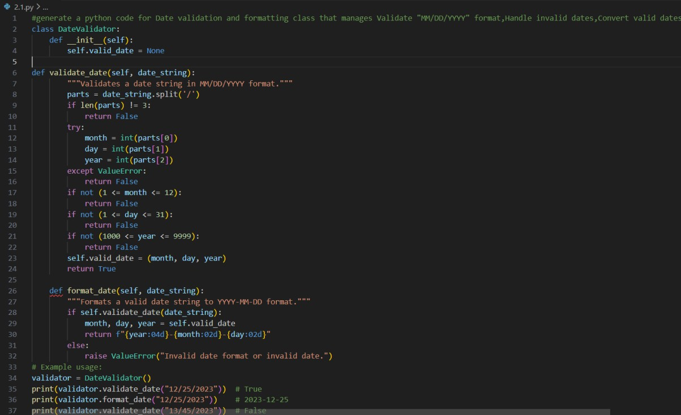
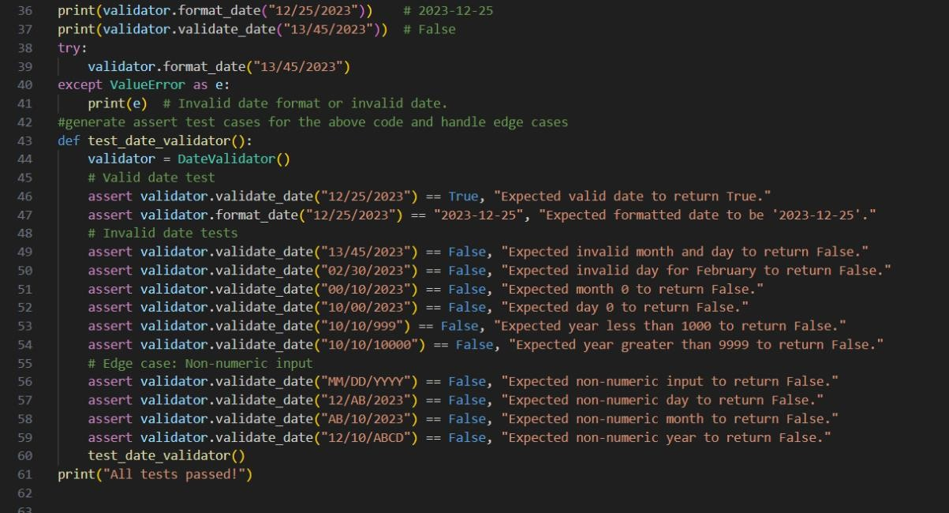

Output:

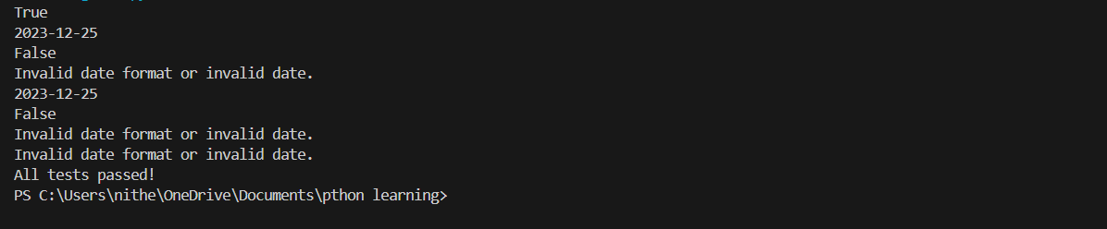

Justification:
The function ensures proper date validation by checking the correct "MM/DD/YYYY" format and detecting invalid calendar dates.
Assert-based tests confirm accurate conversion to "YYYY-MM-DD" and reliable handling of edge cases.

